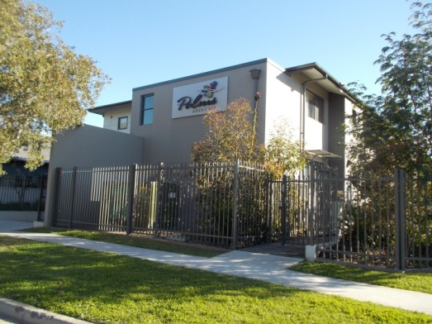

APRIL 2019

NEWSLETTER

A MESSAGE FROM EMMA ALEXANDER

THIS ISSUE

Page | Article
1 | A message from Emma
2 | Star sign, horoscope and birthday celebrations
3 | This and that
4 | Activities to watch out for
5 | Resident Happy Snaps
6 | Humour
7 | A Resident story
8 | Word Search
9 | March Calendar of Events

.“I’ve learned that home isn’t a place, it’s a feeling.”, Cecelia Ahern

Recently my son was writing a speech and the topic he choose to discuss was “It’s now or never”. When he was researching the topic he came across many quotes with all very similar meanings. A lot of people talking about the same thing but not doing anything about it. He decided to continue his speech but referred to the saying “actions speak louder than words”.

The Palms is continually improving, its service, its surroundings and continual education for staff. At a recent audit by the Aged care Quality and Safety Commission they commented on how we were always improving. The result of our recent unannounced accreditation in the new system saw The Palms pass all 44 Standards and to become accredited again for another 3 years. This is a fantastic result and we all should be extremely proud.

I would like to remind everyone that we value any feedback, big or small, good and not so good. If you would like to pass on any feedback, please use the forms located at reception or just approach, Kim Spicer NUM or Emma Alexander, Care Manager. This is the same form I would like members of The Palms to use if they would also like to vote for the next Staff Member of the Month. Jacky, as Consumer Liaison will also be continuing her rounds with residents and families and is also another great source to pass feedback to.

Staff News

At the end of March, The Palms family lost another soul, Craig Hartman our chef passed away suddenly. This came as a great shock to all who knew him. Craig was always present to speak to residents, their families and friends. Craig was known for his roast lunches, delicious scones and beautiful birthday cakes. On behalf of the residents, families, friends and staff we pass on our condolences to Craig’s family.
April Employee of Month
This month the award for staff Member of the Month, goes to a very empathetic, strong and amazing woman. Who not only cares for her many children and pets at home but also cares for our residents as if they were family. Amy LIghtowlers, on behalf of the residents and their families thank you.
Regards
Emma Alexander
Care Manager
Royal Commission Update
Without doubt, the most significant agent for change is the Royal Commission into Aged care. This process is continuing to offer our nation and our industry the opportunity to make the aged care system better. This year there is a clear challenge for our industry, the government and the community at large, to find new better ways to support older Australians to age well. We are all in this together and we must get this right. Which brings me back again to the saying, “actions speak louder than words”.
STAR SIGN

Birth Flower: Daisy and Sweet pea
April’s birth flowers are the daisy and the sweet pea.
The daisy conveys innocence, loyal love and purity. Yet it is also a flower given between friends to keep a secret: the daisy means “Ï’ll never tell”.
While the sweet pea signifies blissful pleasure, on the other hand they are also used to say good-bye. Perhaps Shakespeare had sweet peas in mind when he wrote the immortal words: “Parting is such sweet sorrow”.
BIRTH STONE FOR APRIL: DIAMOND
Diamonds are commonly associated with love which make it the perfect gift for a loved one. While white diamonds are most common, diamonds can be found in a variety of colours including yellow, blue and pink.
Since ancient time, diamonds have been admired objects of desire. Formed 100 miles beneath the Earth’s surface over a billion years ago, diamonds are the hardest gems of all. Diamonds have a long history of folklore; some of which say diamonds were created when bolts of lightning struck rocks, and others said the gem possessed healing powers. For centuries, diamonds have been adorned by women and men regarded as the ultimate gift and a symbol of eternal love.
Today diamonds are still admired all around the world. Until the middle of the twentieth century, there was no standard by which diamonds could be evaluated. GIA created the first, and now globally accepted standard for describing diamonds.
April Horoscope

TAURUS (March 12 – April 19)

Element Earth, Quality Fixed, Ruler Venus

Strengths: Reliable, Patient, practical, devoted, responsible, stable

Weaknesses: Stubborn, possessive, uncompromising
Likes: Gardening, cooking, music, romance, high quality clothes, working with hands.
Dislikes: Sudden changes, complications, insecurity of any kind, synthetic fabrics.

BIRTHDAYS FOR APRIL
Practical and well-grounded, Taurus is the sign that harvests the fruits of labour. They feel the need to always be surrounded by love and beauty, turned to the material world and physical pleasures. People born with their Sun in Taurus are sensual and tactile, considering touch and taste the most important of all senses. Taurus is and Earth Sign just like Virgo and Capricorn and has the ability to see things from a grounded, practical and realistic perspective.

BIRTHDAY CELEBRATIONS WILL BE HELD ON THE 17th OF APRIL
2019
HAPPY BIRTHDAY TO THE FOLLOWING RESDENTS

Alkira
Betty Greig 7th
Jon Roberts 30th

Allambie

Gloria Downes 28th
HAPPY BIRTHDAY FROM ALL OF US HERE AT

THE PALMS!!!

THIS & THAT

WHAT’S ON FOR APRIL

- 1st April Fool’s Day
- 3rd Precious Pats 1.30pm (Alkira)
- 7th Daylight Savings Ends
- 9th Residents and Relatives meeting 2pm
- 12th Entertainer – 2pm Jenny Avery in Alkira Lounge
- 17th Birthday Celebrations
- 19th Good Friday
- 20th Easter Sunday
- 22nd Easter Monday (Public Holiday)
- 23rd Easter Show ends
- 25th ANZAC DAY (Public Holiday)
- 26th Greek Orthodox Good Friday
- 27th Greek Orthodox Holy Saturday
- 28th Greek Orthodox Easter
- 29th Greek Orthodox Easter Monday
BUS TRIPS
9.30am – 12.00 noon
Tuesdays for Allambie Wing

Fridays for Alkira Wing

VISITING HOURS
It would be greatly appreciated if visiting hours can be kept from 10am. Prior to 10am can impact on the ability to deliver care to our residents.

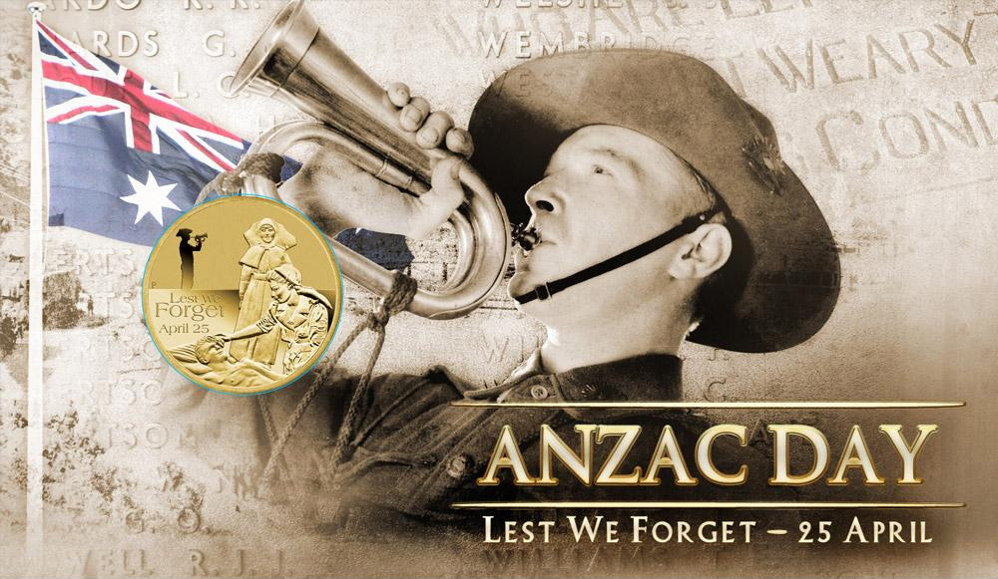
Anzac Day Is one of Australia’s most important national commemorative occaisions. It marks the anniversary of the first major military action fought by Australian and New Zealand forces during the First World War.
Anzac Day falls on the 25th of April each year. The 25th of April was officially named Anzac Day in 1916.

ANZAC – stands for Australiand and New Zealand Army Corps.

On the morning of the 25th April 1915, the Anzacs set out to capture the Gallipoli Penninsula in order to open the Dardanelles to the allied navies. The objective was to capture Constantinople (now Instanbul in Turkey), the capitol of the Ottoman Empire and an ally of Germany.
The Anzacs landed on Gallipoli and met fierce resistance from the Ottoman Turkish defenders. There plan to knock Turkey out of the War quickly became a stalemate and the capmpaign dragged on for 8 months.
At the end of 1915, the allied forces were evacuated. Both sides suffered heavy casualties and endured great hardships. Over 8,000 Australian soldiers were killed. News of the landing on Gallipoli and the events that followed had a profound impact on Australians at home. The 25th April soon became the day on which Australians remember the sacrifice of those who had died in the war.
The Anzacs were courageous and although Gallipoli campaign failed in its military objectives, the Australian and New Zealand actions during the campaign left us all the powerful legacy.
With the coming of the Second World War, Anzac Day also served to commemorate the lives of Australians who died in the war. The meaning of Anzac Day today includes the rememberance of all Australians killed in Military operations.

ACTIVITIES TO WATCH OUT FOR
Easter Raffle
We are running an Easter Raffle. All donations are welcome and tickets are on sale 3 for $5
There are some lovely and yummy prizes so get in quick.
COMMUNITY NEWS

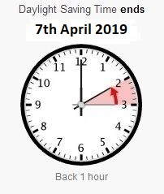
Happy Snaps
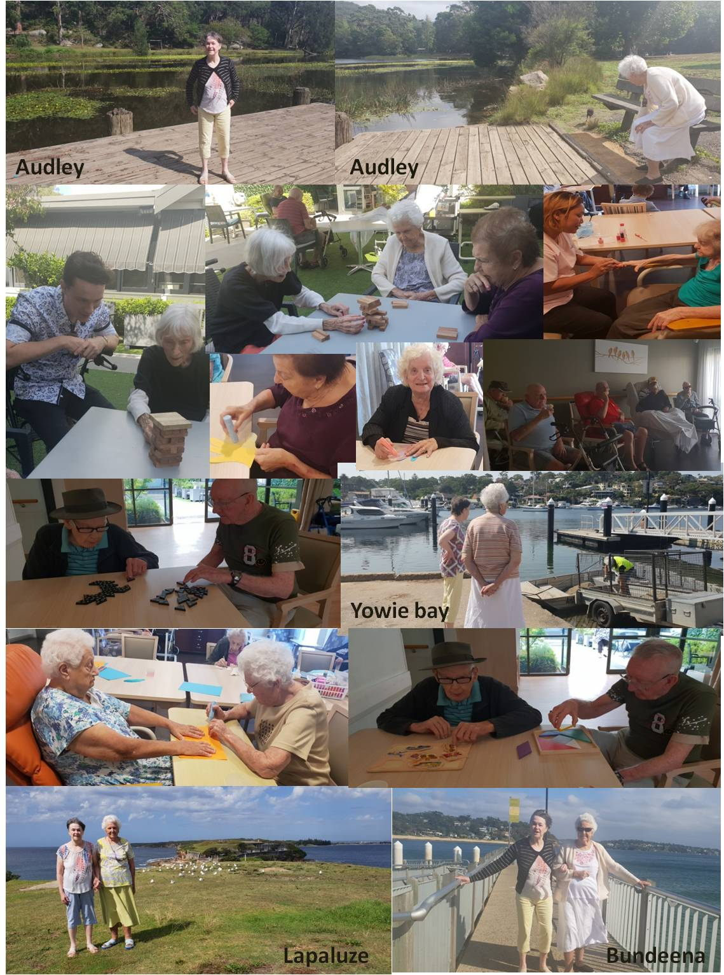
HUMOUR

A snake slithered into a bar and asked the bartender for a drink, “I’m sorry” said the bartender, “but I can’t serve you!” “Why not?” asked the snake. “Because you can’t hold your drink”!

Wife: “What are you doing?”
Husband: “Nothing”
Wife: “Nothing, you’ve been reading our marriage certificate for an hour!”
Husband: “I was looking for the expiry date!”

A customer walked into a bar and said “I’ll have a pint of Less, please”
“Less,” queried the bartender, “What is that?”
“I don’t know either,” said the customer, “but my doctor told me to drink LESS!”

Quote of the Month
All our dreams come true if we have the courage to pursue them
(Walt Disney)

Duke of Edinburgh
The Duke of Edinburgh’s International Award is available to all 14–24 year olds, regardless of their background. The Award is comprised of three levels each progressively more challenging
Bronze Silver Gold
For those over 14 years old For those over 15 years old For those over 16 years old

The Palms will be hosting 4 boys from St Patrick’s school every Tuesday for the next few months. The boys will be chatting and doing activities with the Residents. Please make them welcome.ice, Skill, Physical Recreation and Adventurous Journey. Gold level, participants also complete a Gold Residential Project
ard is available to all 14–24 year olds, regardless of their background
The Award is comprised of three levels each progressively more challenging

Bronze
For those over 14 years old

Silver
For those over 15 years old

Gold
For those over 16 years old
Participants are required to complete four sections at each level: Voluntary Service, Skill, Physical Recreation and Adventurous Journey. Gold level, participants also complete a Gold Residential Project

A story from our Residents

Shark Stay – by Lee Denman

When I was still at school, each Christmas time school holidays, the family would have a 6 week holiday camping at Terrigal.
I developed an ability in surfing even though I was only 12. I used to swim at North Terrigal from about 9am until lunch time. After lunch we went back to North Terrigal and surfed until about 5pm.
At this time it was all body surfing at which I became really proficient and used to swim right out about 200m with the surfing boys.
The Christmas tides were in at this time and the average wave was about 6 foot or higher and was strong enough to take you about 200m from where you were right into the beach.
One particular day I was out there with a group of boys when one of them sang out “get this one boys it’s a beauty”. They all got on it but I thought the one behind was even bigger so I waited for it. As I dog paddled waiting for the wave a large shark fin passed me about 10-12 feet away. I thought it was no good trying to out swim him so I waited for my wave. It seemed a long time but it was probably only seconds until my wave arrived. Luckily I caught the wave right in to the beach. When I went to stand up my legs were like jelly. As I tried to stand up the shark bell rang so I was the first one out of the water. We weren’t out of the water for long as we waited for the shark to swim away and then we were back out on the big waves again. I didn’t tell mum about the shark.

